

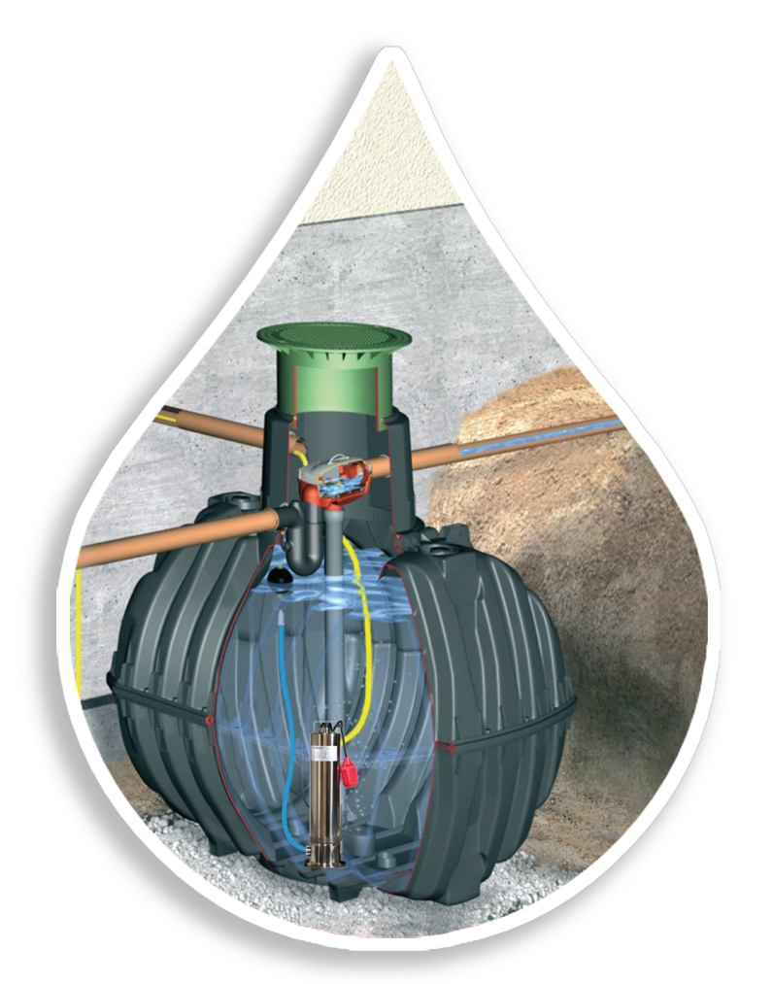
A rainwater harvesting system can collect up to 1,250 gallons from 2,000 square feet of roof area during a single 1” rain event. Our systems typically include the capture of air conditioning condensate, which increases the useful supply even further. Our expert staff can help with all the design and technical assistance to make your system as efficient as possible.

- Irrigate during watering restrictions
- Provides a payback by reducing or eliminating water bills
- Tax credits in many municipalities
- Most systems apply toward storm-water mitigation requirements
- Conserves water from natural sources
- Reduces energy and other byproducts of municipal water treatment
- Provides a sustainable on-site water supply
- Reduces erosion
- Contributes to aquifer and groundwater recharge
- Aligned with low-impact development building principles
- Can help supplement low-producing wells
- USGBC LEED Green Building credits

We are your one stop shop for your complete rainwater harvesting system package! Let us help you design and size the perfect system for your needs.
INSERT LOGO
Installing a rainwater harvesting system provides numerous benefits:

